Checkmarx exercise

Objective:
Create an application within a Kubernetes cluster (Minikube or K3d) with Jenkins (dynamic worker pods), PostgreSQL, and Grafana, all exposed via Traefik
High Level Design:
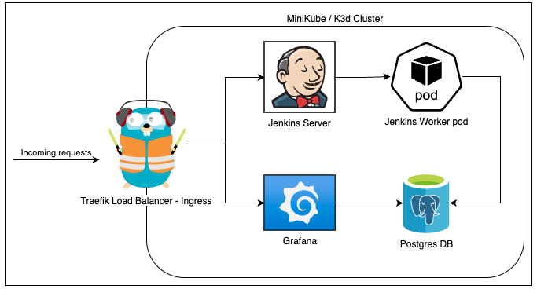

Part 1: Setup and Deployment
- Prepare Your Environment
  - Install Minikube or K3d (your choice) on your local system.
  - Ensure you have kubectl, helm, and Docker installed.
  - Set up a basic Kubernetes cluster with Minikube or K3d.
- Deploy Postgres
  - Deploy a PostgreSQL using Helm with persistent storage.
  - Bonus: Secure the database connection using Kubernetes Secrets.
- Deploy Jenkins
  - Deploy Jenkins in HA mode as a Kubernetes deployment using Helm with persistent storage.
  - Configure Jenkins to use a shared Kubernetes namespace for worker pods.
- Configure DSL Jobs
  - Create a Jenkins Job DSL script that launches dynamic Kubernetes worker pods on demand. These pods will record the current date and time into the database. The job should be scheduled to run every five minutes.

Part 2: Load Balancer
- Deploy a Load Balancer
  - Set up Traefik as a Load Balancer and Ingress Controller.
  - Expose Jenkins, Grafana and Traefik.
Do not use port forwarding! all services should be accessed via Traefik ingress.

Part 3: Monitoring with Grafana
- Set Up Grafana
  - Deploy Grafana using Helm
  - Apply Terraform to configure a Grafana dashboard that visualizes key performance metrics of the PostgreSQL database CPU, memory, and throughput metrics.

Part 4: Deployment Script
- Create a bash script
  - Gets an install/uninstall param
  - Installs the entire solution locally

Submission
- Store all required code (YAML/Helm manifests, Jenkins DSL scripts, Terraform files, and Bash deployment scripts) in a private GitHub repository. on your CX GitHub account and not in an organization repository.
- Share access to the repository as needed for review and validation. Mail: alon.rosenhek@checkmarx.com

